
Mathematics Essential

Name: ______________________

Task 1.5 – Unit 1

Assessment type: Response - Skills

Conditions:

Time for the task: 15 minutes

In class, calculator permitted
Marks: 18 marks __________/18

Task weighting:

2% of the school mark for this unit

_________________________________________________________________________________

- Estimate the capacity of each of the following (using mL, L or kL):

- The classroom

- Your school bag
- The photocopy paper box on my desk
- The bottle on my desk

- a) Round $21.3598 to the nearest cent

b) Round $21.3598 to the nearest 5 cent

c) Round $21.3598 to the nearest dollar

d) Round $29.4589 to the nearest dollar

3. Find
a) What percentage of $320 is $80

b) What percentage is 5 cm of 2m
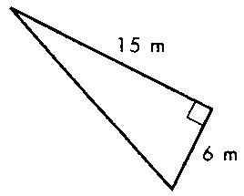

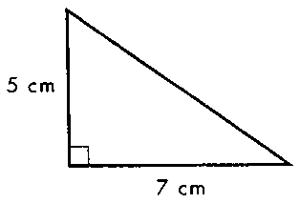
4. Find the area of these two triangles?
a)

b)

5. a) 5.5 days is how many minutes?
________________ minutes
b) March, April & May – how many days?
________________ days

6. a) Write in your own words the meaning of Salary as a method of payment

b) Write in your own words the meaning of Wages as a method of payment

Mathematics Essential Solutions

Task 1.5 – Unit 1

Assessment type: Response - Skills

Conditions:

Time for the task: 15 minutes

In class, calculator permitted

Marks: 18 marks ______________/18

Task weighting:

2% of the school mark for this unit

_________________________________________________________________________________

- Estimate the capacity of each of the following (using mL, L or kL):

a) The classroom
Will vary!!
10 x 7 x 3 = 210 m³ = 210 000kL
b) Your school bag
~ 20L
c) The photocopy paper box on my desk
~ 15L
d)The bottle on my desk
~ size of bottle you use mL

- a) Round $21.3598 to the nearest cent
$21.36
b) Round $21.3598 to the nearest 5 cent
$21.35
c) Round $21.3598 to the nearest dollar
$21.00
d) Round $29.4589 to the nearest dollar
$29.00

3. Find
a) What percentage of $320 is $80
25%

b) What percentage is 5 cm of 2m

2.5%


4. Find the area of these two triangles?
a)

= 17.5 cm² less 1 if no units

b)

= 45 m² less 1 if no units

5. a) 5 days 6 hrs is how many minutes?
___7560 ____ minutes
b) March, April & May – how many days?
_____92 ____ days

6. a) Write in your own words the meaning of Salary as a method of payment
A fixed regular amount, e.g. yearly divided into weekly/fortnightly pay

b) Write in your own words the meaning of Wages as a method of payment
A fixed hourly, daily or weekly amount for work done.

